ADOPTING INDUSTRY 4.0 TECHNOLOGIES: CHALLENGES, OPPORTUNITIES AND STRATEGIES FOR SMALL & MEDIUM ENTERPRISES

4 – 8 OCTOBER 2021

Sponsored by the

SINGAPORE COOPERATION PROGRAMME

under the

SINGAPORE COOPERATION PROGRAMME TRAINING AWARD

to be conducted by

**MINISTRY OF TRADE AND INDUSTRY ACADEMY**

with

**CIVIL SERVICE COLLEGE**

and

**REPUBLIC POLYTECHNIC**

**Singapore Cooperation Programme**

Singapore has provided technical assistance to other developing countries since the 1960s. As a country whose only resource is its people, Singapore believes that human resource development is vital for economic and social progress. Singapore itself has benefited from training provided by other countries and international organisations.

In 1992, the Singapore Cooperation Programme (SCP) was established to bring together under one framework the various technical assistance programmes offered by Singapore. Through the SCP, the range and number of training programmes were increased to share Singapore’s development experience with other developing countries.

To date, over 132,000 officials from more than 180 countries and territories have participated in our courses and study visits. The SCP is managed by the Technical Cooperation Directorate of the Ministry of Foreign Affairs, Singapore.

**Ministry of Trade and Industry Academy**

The Ministry of Trade and Industry (MTI) Academy was established in March 2021. The MTI Academy has taken over the functions of the Trade Academy (instituted in 2011), and expands to other areas such as Industry, foreign economic and climate policy, governance of think tanks, and country programmes. The Academy seeks to forge partnerships and collaborate with think-tanks and organisations - national and international.

As part of Singapore’s support for the rules based multilateral system and international cooperation, the Academy co-organises third country training programmes to enable the officials from third countries to build capabilities to enhance their participation in the global economy.

**Civil Service College**

Civil Service College (CSC) is the central learning institution for the Singapore Public Service. It plays a pivotal role in nurturing and developing people for a first-class Public Service. As a Statutory Board under the Prime Minister’s Office, we endeavour to be the heart of learning excellence and development for the Singapore Public Service.

CSC partners public and private sector organisations as well as academia and international government agencies to exchange best practices and experiences in leadership, policy development, public administration and public reforms.

**Republic Polytechnic**

The first educational institution in Singapore to leverage the Problem-based Learning approach for all its diploma programmes, Republic Polytechnic (RP) has seven schools and one academic centre offering 37 full-time diplomas in Applied Science, Engineering, Management and Communication, Hospitality, Infocomm, Sports, Health & Leisure, and Technology for the Arts.

RP's Academy for Continuing Education offers a comprehensive suite of lifelong learning programmes to provide adult learners with skills upgrading opportunities. For more information, visit <http://www.rp.edu.sg>.

**Course Objectives**

The programme shares Singapore government’s approach in assisting Small & Medium Enterprises (SMEs) to navigate Industry 4.0 challenges and opportunities. It will introduce participants to the development and implementation of customised strategies and solutions promoting the adoption of Industry 4.0 among SMEs. By the end of the course, participants will have the insight and tools to develop an Industry 4.0 policy for SMEs in their countries.

**Synopsis**

Topics to be covered include:

* An introduction to Industry 4.0 technologies
* The benefits and challenges for SMEs in adopting Industry 4.0 technologies
* Customising Industry 4.0 strategies and solutions for SMEs
* Preparing the SME workforce for Industry 4.0
* Develop an Industry 4.0 policy for SMEs

**Methodology**

This course will be delivered for up to **30 participants** through **synchronous e-Learning** (“live” e-learning sessions) on Zoom. This includes “live” interactions with officials from several Government of Singapore agencies as well as Singapore industry. Participants will also participate in 3 virtual tours that showcase Industry 4.0 in action in Singapore.

**Regulations**

Participant are required to comply with the following:

* Strictly observe course schedules and not miss training sessions, and;
* Carry out instructions and abide by conditions as may be stipulated by the nominating Authority or Government and the Government of Singapore and its appointed trainer, with respect to the course.

**Duration**

The course will be held over 5 days from **4 to 8 October.**

The synchronous sessions will be conducted from **1100h to 1600h** (Singapore Time; UTC/GMT +8 hours) daily, with breaks when appropriate. The programme schedule is at Annex (subject to changes).

**Application Information**

Applicants should be:

* Mid-to-senior level government officials involved in developing Digital/Industry 4.0 transformation initiatives and programmes;
* Able to attend all the synchronous e-learning sessions. They will require an internet-enabled device with a functioning webcam, microphone and audio;
* Nominated by their respective Governments;
* Proficient in both spoken and written English as the course is conducted fully in English without translation; and
* In good health.

**Terms of Award**

The course is sponsored by the Government of Singapore under the Singapore Cooperation Programme Training Awards.

**Application Procedure**

(Closing date for nomination: **10 September 2021**)

The Government of Singapore is pleased to invite the respective National Focal Point for Technical Assistance (NFP) to nominate **one (1)** suitable applicant. Selection of candidates will be based on merit.

Should there be more applicants than training places, the Government of Singapore seeks the understanding of the respective NFP in the event that its nominee(s) is not selected.

All nominees are to submit their applications online **at** [**https://go.gov.sg/sme2021**](https://go.gov.sg/sme2021)by **10 September 2021**. NFPs are also required to

endorse nominees via email links. Instructions and FAQs for Applicants and NFPs can be found at the links below:

* Applicants: <https://go.gov.sg/start-guide>
* NFPs: <https://go.gov.sg/start-nfp>

**Note:**

* Participants who complete all course assignments and attend at least **66%** of ‘live’ e-learning sessions, will receive a certificate of completion from the SCP.
* Applicants should refrain from making telephone and email inquiries on the status of their applications.
* The **Ministry of Foreign Affairs, Singapore** will inform all applicants of the outcome of their applications. The NFP will also be informed directly.

#### Follow us at:

* SCP Website: [www.scp.gov.sg](http://www.scp.gov.sg)
* Facebook: [www.facebook.com/SCPFriends](http://www.facebook.com/SCPFriends)

**. . . . .**

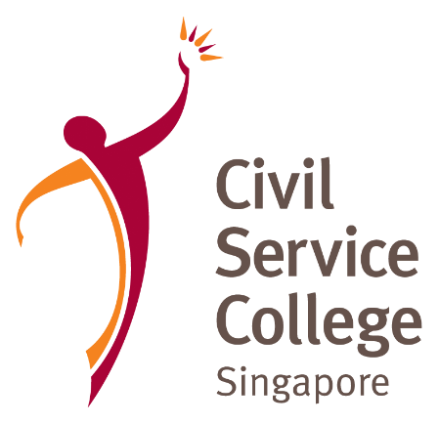Annex

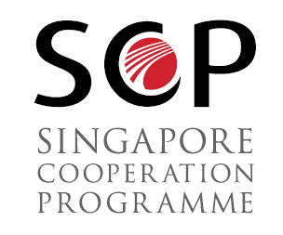

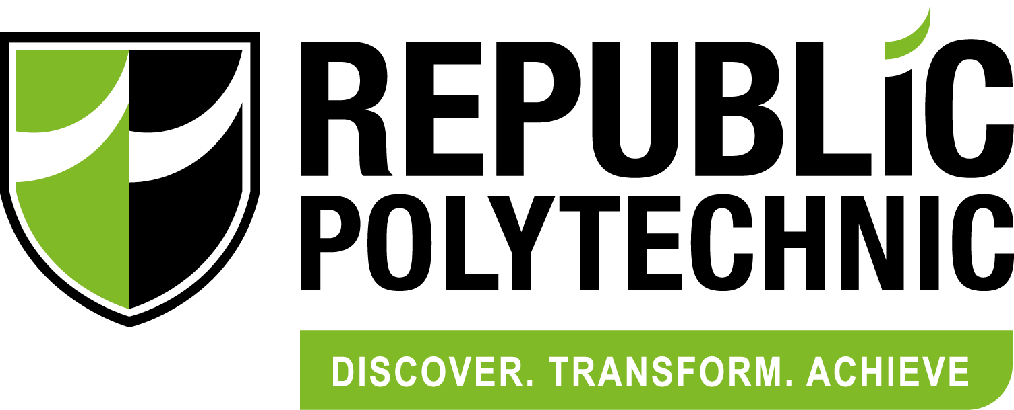

Draft Programme Schedule (as at 10 August 2021)

|  |  |
| --- | --- |
| **Day 1 (4 Oct)** | **Topic and Description** |
| **10:45am to 11:00am** | **Opening Ceremony** |
| **11:00am to 11:15am** | **Programme Introduction & Welcome** |
|  | This segment will be an introduction to the programme’s anchor facilitators from Republic Polytechnic (RP) and Civil Service College (CSC) and a brief on programme objectives, coverage & format |
| **11:15am to 1:15pm** | **Introduction to Industry 4.0 Technologies** |
|  | Participants learn about Industry 4.0 technologies for themselves through a virtual “hands-on” experience followed by sharing & discussion. |
| **1:15pm to 2:15pm** | **Industry 4.0 In Action - Robotics (Virtual Tour 1)** |
|  | Participants will go on a virtual tour to witness the end-to-end integration of Industry 4.0 technologies in a manufacturing environment. A product to be assembled will be featured, with smart devices and robotics integration. Manufacturing information will be monitored remotely across two different sites. |
| **2.15pm to 3pm** | **Lunch Break** |
| **3.00pm to 4:00pm** | **Panel Discussion: Benefits and Challenges facing SMEs in adopting Industry 4.0 Technologies** |
|  | Technical experts, working closely with SMEs in Industry 4.0 adoption and the management of several Singapore SMEs who have digitally transformed their processes, will share on-ground experiences and observations on the benefits and challenges facing SMEs in adopting Industry 4.0 technologies. |
|  | |
| **Day 2 (5 Oct)** | **Topic and Description** |
| **11:00am to 12:00pm** | **Singapore’s Digital Transformation Strategy for SME’s** |
|  | This session starts with a sharing of Singapore’s Industry Transformation Maps (ITMs) as an overall guiding framework for all industries. Given SMEs’ special considerations of cost and ease of technology adoption, it describes Singapore’s ecosystem approach, which involves integrating efforts across multiple government agencies, industry associations, financiers, Institutes of Higher Learning and MNCs, to help SMEs visualise transformation possibilities and enable SMEs to access, afford and adopt appropriate technologies and solutions for improved productivity. |
| **12:00pm to 1:00pm** | **Industry 4.0 In Action - Lean Supply Chain 4.0 (Virtual Tour 2)** |
|  | This virtual tour emphasises the importance of lean processes before automation. The ‘before and after’ lean operations in an assembly and warehouse operations processes will be showcased, and how operations can be digitalised thereafter. |
| **1:00pm to 2:00pm** | **Smart Industry Readiness Index (SIRI)** |
|  | In this session, a speaker from Singapore’s Economic Development Board (EDB) will share on the Singapore-developed Smart Industry Readiness Index (SIRI) tool for assessing a company's digitalisation status and journey. SIRI assessors from Republic Polytechnic will also share their experience in helping SMEs of varying stages of growth and digital maturity along their Industry 4.0 transformation journey. |
| **2.00pm to 2.45pm** | **Lunch Break** |
| **2:45pm to 4:00pm** | **Government Digitalisation Grants/Schemes: Shortlisting and Financing SME-appropriate Technologies** |
|  | Infocomm Media Development Authority (IMDA) will share about its SMEs Go Digital Programme that provides grants for SMEs to adopt digital solutions and technologies that improve productivity and grow revenue. The agency will also touch on how it works with partners like ESG and Industry Bodies to identify and shortlist SME appropriate technologies. Speakers from an Industry Association in Singapore will be invited to share how Industry Associations work closely with Government agencies in Singapore to advance digital transformation of SMEs, and an SME will be invited to share on the grants/schemes received. |
|  | |
| **Day 3 (6 Oct)** | **Topic and Description** |
| **11:00am to 12:00pm** | **Preparing the SME workforce for Higher-Skill Roles Brought about by Industry 4.0 Technologies and Best Practices** |
|  | This section explains the importance of human capital development, and not just technology advancement, for the successful and sustainable digital transformation of SMEs. The different skills development initiatives of Singapore such as SkillsFuture will be explored in detail. Additionally, an SME speaker will be invited to share about the company’s experience in upskilling its employees. |
| **12:00pm to 1:00pm** | **Industry 4.0 In Action - Additive Manufacturing and Makerspace (Virtual Tour 3)** |
|  | This virtual tour introduces the basics of additive manufacturing and how this technology is easily accessible to companies. Innovations are being fostered through makerspaces around the world, where anyone can create products easily. |
| **1:00pm to 2:30 pm** | **Initiatives in the Region Relating to Industry 4.0** |
|  | This session provides a holistic view of the region’s efforts and its relation to Singapore’s approach. Additionally, participants will be requested to provide a snapshot of the Industry 4.0 efforts in their country. |
| **2.30pm to 3.15pm** | **Lunch Break** |
| **3.15pm to 4:00pm** | **Reflections and Sharing: Key Learnings from Singapore’s Transformation Strategy for SMEs** |
|  | In this session, participants will be guided to reflect and share (i) their key learnings and insights from Day 1 to 3 and (ii) policy areas they would like to consider when developing their country’s digital transformation strategy for SMEs. |
|  | |
| **Day 4 (7 Oct)** | **Topic and Description** |
| **11:00am to 4:00pm** | **Policy-in-Practice: Develop an Industry 4.0 Support Policy for SMEs** |
|  | Building on Day 3, this section provides guiding tools to assist participants in developing an appropriate Industry 4.0 support policy for SMEs, for their respective countries. It will introduce participants to the Singapore’s Policy Development & Evaluation Cycle (PDEC) and go into the details of each phase, namely: (i) Initiate Policy; (ii) Identify and Analyse Problem; (iii) Identify and Evaluate Options; (iv) Decision; (v) Implement; and (vi) Evaluate Outcome. Participants will then have a skills-based exercise, using learning points and insights from the first three days, to practise developing policies using the policy planning cycle.  *Note: Lunch time is from 2.00pm-2.45pm* |
|  | |
| **Day 5 (8 Oct)** | **Topic and Description** |
| **11:00am to 3:45pm** | **PDEC Project Discussions and Presentation** |
|  | This segment is a continuation of Day 4 of the skills-based exercise. Participants will break out into groups and discuss a policy issue using the policy planning cycle (with a given topic relevant to the entire programme). Groups will then present their work with feedback sessions at the end of each presentation.  *Note: Lunch time is from 2.00pm-2.45pm* |
| **3:45pm to 4:15pm** | **Closing Remarks and Programme Evaluation** |