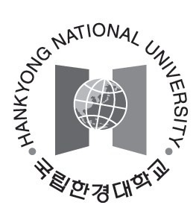
Hankyong National University

Personal Statement & Study Plan
(For graduate program Applicants)

Please type or print in English.
Please feel free to attach additional sheets if necessary.
ACADEMICS

Current or most recent school or institution attended _____________________________________________
Entry Date ____________(Expected)Degree Conferred _________________Graduation Date _____________
mm/yyyy mm/yyyy
Institution Address __________________________________________________________________
Number & Street
______________________________________________________________________________ City/Town State/Province Country ZIP/Postal Code
Applicant’s Name ______________________ Birthdate ________ Department of your choice _____________
mm/dd/yyyy
PERSONAL STATEMENT

Short Answer
- Please describe any unique characteristics of your institutions or distinctive qualities to your previous education. Give a brief account of the curriculum and mention any set of courses which were instructively significant in shaping your current academic interests.

- In relation to your academic interests and personal perspectives, please explain your motives and scholastic purposes for applying to the Program. You may briefly elaborate in addition on any of your extracurricular activities or work experiences in the space below.

Personal Essay
- This personal essay helps us become acquainted with you in ways different from courses, grades, test scores, and other objective data. Given your personal background, evaluate a significant experience, achievement, risk you have taken, or; discuss some issue of personal, local, or international concern and its importance to you, or; describe a person who has had a significant influence on you, and describe that influence. We are looking for an essay that will help us know you better as a person and as a student.

STUDY PLAN
Please explain in some detail your purpose in studying at Hankyong National University and your plans for study. Be as specific as you can regarding your academic interests and the curriculum you expect to follow in achieving your goals.

THESIS TOPICS
Please specify your thesis topics. It would be a practical reference to closely review the list of professors with their professional area(given in program information attachment #2) to have your future thesis supervisor. Applicants who successfully admitted have to write thesis proposal and submit it on the date they arrive at HANKYONG National University (July 30).

Required Signature

I certify that all information submitted in the admissions process – including the application, the personal essay, any supplements, and any other supporting materials – is my own work, factually true, and honestly presented. I understand that I may be subject to a range of possible disciplinary actions, including admission revocation or expulsion, should the information I’ve certified be false.
Signature ________________________________________________________ Date___________
mm/dd/yyyy

