Inception Report
All applicants to the program need to make an Inception Report using the format below and submit it with the application form. This report will be used for the selection of the program’s participants among applicants. Therefore, this report must be TYPED. (The report should be within 6 pages.)
*Please answer clearly and concisely. You may expand the space of each row and column of the format, if necessary.
To be submitted in Word/PDF format together with your Application Form.
Any HANDWRITTEN and INCOMPLETE report will be automatically DISQUALIFIED.

1 Basic Information
1 | Name of applicant  (Country)
2 | Name of your organization
3 | Name of your department, division, section and/or unit.
4 | Name of your job title and duty/assignment
5 | Please attach Organization Chart which you belong to (English preferable)

2 General Information on the Country
1.Socio-economic conditions, population, natural environment
2. Principal natural disasters in your country and their frequency
3. The disaster management system with the description on division of roles between national government and local government
4. National budget allocation for disaster risk reduction(DRR): please indicate the percentage in the total national budget and describe DRR budget breakdown.
5. Promotion of community awareness and involvement in DRR: Please describe the national policies/policy implementation and community reaction in general

3 Information regarding your duty
1.The functions and authorities of your organization/department regarding promotion of community-based disaster risk reduction.
2. Present situation in your duty regarding promotion of CBDRR. Please attach photos with explanation showing CBDRR activities related to your organization.
<Examples in Japan>
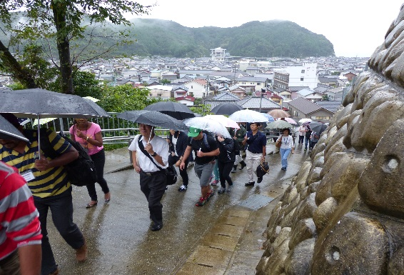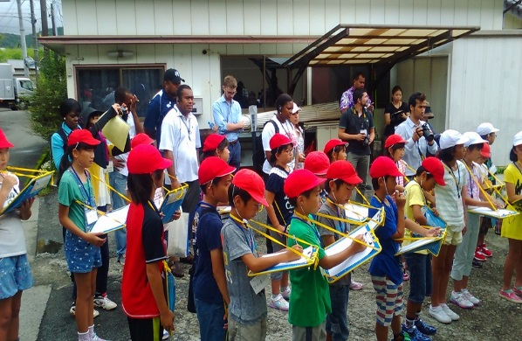
Evacuation drill in community Disaster risk reduction education in school
3. Challenges/Issues regarding promotion of CBDRR in your country/organization.
4. Your expectation to this program

