VI. ANNEX-1:

Job Report
Food Safety Administration JFY 2016

Remarks 1: The Report should be typewritten in English (12-point font, A4 size paper), and total pages of the report must be limited to 3 pages (not including organization chart).
Remarks 2: Each participant is required to have presentation in about 10 minutes based on this Job Report and IAS at the early stage of the training in Japan, for the purpose of making the training more effective and fruitful by comprehending the situations and problems of the participants each other.
For the presentation, it is recommendable to include visual items such as photos or videos to show your country’s staple foods, food processing facilities, street vendors, etc.

a) Food safety situation in your country
1) Please describe briefly on food related facilities’ hygiene, supervision, food inspection and consumers’ attention.
2) Three (3) major issues that need to be solved or improved.

b) Organization Chart
Referring to the example below, draw the chart of your organization and indicate your department / division / section with a double line.
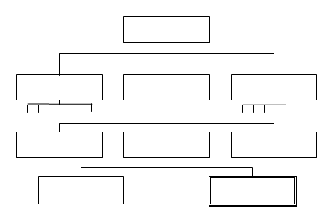

c) Role of Organization

d) Your present position and duties relating to the roles of food safety.

