|  |  |  |  |  |
| --- | --- | --- | --- | --- |
| **C:\Documents and Settings\shula\Local Settings\Temporary Internet Files\Content.Outlook\OSN7BLMZ\Unido_logo_darkblue.jpg** | M:\MCTC WEBSITE\LOGOS\MCTC logo.JPG | [http://t3.gstatic.com/images?q=tbn:PrqzKeglfwQbsM:http://upload.wikimedia.org/wikipedia/commons/thumb/b/b2/Coat_of_arms_of_Israel.svg/418px-Coat_of_arms_of_Israel.svg.png](http://images.google.co.il/imgres?imgurl=http://upload.wikimedia.org/wikipedia/commons/thumb/b/b2/Coat_of_arms_of_Israel.svg/418px-Coat_of_arms_of_Israel.svg.png&imgrefurl=http://lancestrate.blogspot.com/2008_12_01_archive.html&usg=__2peLitEH5itflFPTDuXYT5I4m_k=&h=514&w=418&sz=91&hl=iw&start=13&itbs=1&tbnid=PrqzKeglfwQbsM:&tbnh=131&tbnw=107&prev=/images?q=simbol+of+the+state+of+israel&hl=iw&sa=X&tbs=isch:1) **STATE OF ISRAEL** | **mashav-pict** | **cinadco** |
| **MASHAV – Israel’s Agency for International Development Cooperation**  **Ministry of Foreign Affairs MCTC – The Golda Meir Mount Carmel International Training Center**  **CINADCO – Center for International Agricultural Development Cooperation Ministry of Agriculture and Rural Development**  In cooperation with  **UNIDO – United Nations Industrial Development Organization** | | | | |
| **Regional Workshop on**  **Agribusiness –**  **A Tool for the Empowerment of Rural Women**  **November 16-December 9, 2015**  **Haifa, Israel** | | | | |
| https://lh6.googleusercontent.com/-9r9kCWMIvVQ/VUi3NHJsLgI/AAAAAAABnEY/tCdNtr_Jzho/w958-h639-no/IMG_8468.JPG | | | | |

**ABOUT THE WORKSHOP**

**Background**

Addressing gender equality and the empowerment of women, as well as increasing attention to economic and social development strategies within rural areas, are globally recognized as critical aspects of sustainable development. Rural women play a critical role in rural economies and societies in both developing and developed countries. Across the world, rural women have proven their commitment and resourcefulness in finding or adapting new ways to improve their own lives, as well as those of their families and communities.

While agriculture remains one of the main pillars of the rural economy within most developing countries, in today’s rural world, new forms of income and employment opportunities have emerged that are non-agricultural, or linked to agriculture through related services.

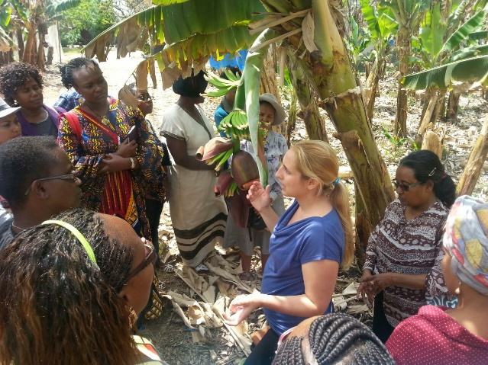

The agricultural sector and food production have been among the main pillars of the Israeli economy since Israel's declaration of independence, with the investment of massive funds for continuous research and development. However, over the last few years, the number of active farmers in Israel has been drastically reduced. There is a continuous exit of small farmers from business, due to the limitation of land and water and an ever increasing trend away from farming to other professions. Today's farmers need to adapt to this process by making the required transition from being simple producers to becoming managers of an agricultural enterprise, armed with the latest technologies and know-how, as well as an understanding of the market.

Agricultural diversification, coupled with intensive Research and Development and effective up-to-date extension services for rural farms, will prevent the transformation of additional farming lands for non-agricultural use and keep farmers and rural professions in business. As technology and intensive agricultural methods change the conditions of agricultural production, farmers need to explore other alternativesin order to remain in the ruralareas.

Taking into account current trends, Israel is ready to share its rich experience in agribusiness for the enhancement of rural development.

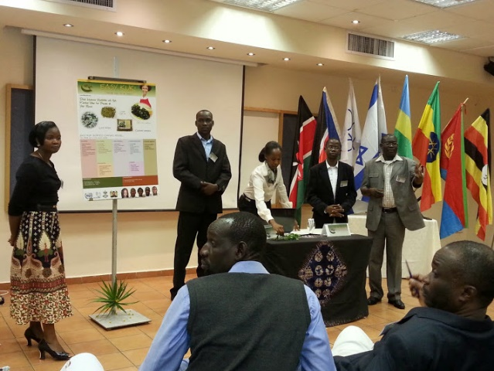

**AIMS**

The proposed training program aims at contributing to rural women’s empowerment by exploring agricultural entrepreneurship, as well as additional, farm related components of the rural economy contributing to income generation and employment, taking into consideration the adaptability of methods and technologies, to meet local conditions in each participant's country. The participants will be exposed to the various aspects of planning, development, and management of small businesses in agro-industries, so that by the end of the workshop they are able to:

* Use the tools of value chain analysis to elaborate growth strategies;
* Organize, supervise, and manage farm production effectively and profitably;
* Initiate, organize, and manage small agribusiness projects;
* Provide tools for supporting small scale businesses in rural areas;
* Plan and organize small and large agriculture enterprises with an emphasis on the entrepreneurial concept;
* Improve communication and management skills.

**THE PROGRAM**

The workshop will be held at two of MASHAV’s training centers and will include professional lectures and visits on the following subjects:

|  |  |
| --- | --- |
| **At MCTC – The Golda Meir Mount Carmel International Training Center**   * Entrepreneurial Training – Business Laboratories: How to start and manage a microenterprise * Marketing strategies for small businesses  in the rural areas * Women in business networking * Support systems in Israel and best practices in promoting innovative entrepreneurship * Rural Tourism | **At CINADCO – The Center for International Agricultural Development** **Cooperation**   * Agriculture and rural development * New trends in modern agriculture (technological advancements, nutritional concerns, water/energy management) * Implementation of agricultural projects * Women’s entrepreneurship in agriculture * Branding and marketing agricultural produce * The integration between research, extension, and applied agriculture |

**Throughout the training, exchange of experiences among participants will be encouraged, as it provides a valuable adjunct to lectures.**

**Study visits will be organized to observe entrepreneurial initiatives in agriculture.**

**As part of the training program, the participants will submit proposals for agribusiness projects that they intend to carry out in their communities.**

**CERTIFICATE**

Upon completion of the workshop, the graduates will receive a certificate confirming their attendance and active participation.

**REQUIREMENTS**

The workshop is geared towards policymakers, professionals, and practitioners involved in agriculture and rural development, as well as representatives of the agriculture private sector. Candidates should hold an academic degree in related disciplines and have at least five years of professional work experience in related fields.

A full command of English is required.

**APPLICATION**

Application forms and other information can be obtained at the nearest Israeli mission and on Israel's Ministry of Foreign Affairs' website: <http://mashav.mfa.gov.il> (in: Courses Registration Forms).

Completed application forms, including the medical form, should be sent to the relevant Israeli mission (which will forward them to the MCTC Training Center in Israel) **by or before September 15th, 2015.**

One additional copy of the application must be forward to Ms. Nuria Levy ([nuria@mctc.org.il](mailto:nuria@mctc.org.il)) at MCTC.

**ABOUT MASHAV**

MASHAV, Israel’s Agency for International Development Cooperation at Israel’s Ministry of Foreign Affairs, was founded in late 1957 and is responsible for the design, coordination, and implementation of the State of Israel’s development cooperation programs.

MASHAV concentrates on human and institutional capacity building by sharing Israel’s own development experience and expertise, imparting know-how and transferring innovative technologies and tested methodologies adaptable to a developing country’s needs.

MASHAV’s approach is to ensure social, economic, and environmental sustainable development, joining the international community's efforts to implement the Millennium Development Goals by 2015.

In the event of natural disasters, MASHAV also provides humanitarian assistance and participates in reconstruction and rehabilitation efforts. Read more at [mashav.mfa.gov.il](http://mashav.mfa.gov.il).

**ABOUT MCTC**

The Golda Meir Mount Carmel International Training Center (MCTC) was established by MASHAV in 1961 to assist in the training of women engaged in community work in the newly emerging states in Africa and Asia.

Since the establishment of MCTC, nearly 20,000 participants from some 150 countries in Asia, Africa, Europe, Central Asia, Eastern Europe, Latin America, Middle East, Oceania, and the Caribbean have attended more than 650 capacity building programs and 28 International Conferences for Women Leaders conducted in Israel. Hundreds more participants are reached annually in on-the-spot training programs abroad.

MCTC focuses on three areas of study: Community Development, Organization and Management of Microenterprises, and Early Childhood Education, all with gender as a cross-cutting issue. In each training program there are up to 30 women and men from ten to 27 countries. Usually two workshops are conducted concurrently in different languages (English, French, Spanish, Russian, or Arabic).

The Center is located on Mount Carmel in Haifa. The building consists of living accommodation, classrooms, and recreation and dining facilities. A library specializing in education, social sciences and humanities, and a computer laboratory with internet access serve the participants.

MCTC enjoys the active cooperation of a number of international organizations, governmental and non-governmental organizations, and development authorities. For more information visit [www.mctc.org.il](http://www.mctc.org.il) or write to [mctc@mctc.org.il](mailto:mctc@mctc.org.il).

**ABOUT CINADCO**

The Center for International Agricultural Development Cooperation (CINADCO) is a part of Israel's Ministry of Agriculture and Rural Development. Since 1958, CINADCO has been in charge of the international agricultural program conducted by MASHAV in Israel and abroad. CINADCO's activities consist of international, regional, and country tailor-made courses in Israel, on-the-spot courses, long- and short-term project planning, and advisory missions. Israeli experts have also been sent to different locations around the world to conduct projects and share their expertise in various aspects of agricultural production, extension and project planning. See more at <http://www.cinadco.moag.gov.il/cinadco>.

**ABOUT UNIDO**

The United Nations Industrial Development Organization (UNIDO) is a Specialized Agency of the UN system dedicated to the promotion of sustainable industrial development. It counts 174 Member States and delivers technical assistance services in over 100 countries. UNIDO’s Agribusiness Development Branch provides technical cooperation services to assist developing countries add value to their agricultural output and generate employment opportunities in off-farm activities, thereby contributing to increased food security and reduction of poverty.

The services of the Branch aim at linking resources and markets in agribusiness value chains, strengthening forward and backward industrial linkages to support sustainable livelihoods and economic transformation. Their benefits extend to poor and marginalized rural population groups, to urban agro-industries, and to communities facing human security challenges or requiring urgent supplies of agricultural equipment and/or the rehabilitation of crisis-damaged agro-industries. Visit <http://www.unido.org> for more information.

|  |  |
| --- | --- |
| **For further information please contact:**  **d-new jpg - MCTC building** | **C:\Documents and Settings\shula\Local Settings\Temporary Internet Files\Content.Word\Cinadco-Center (1) (2).jpg** |
| **The Golda Meir Mount Carmel International Training Center (MCTC)**  POB 6111, Haifa 3106002, Israel  Tel: 972-4-8375904 Fax: 972-4-8375913 e-mail: [nuria@mctc.org.il](mailto:nuria@mctc.org.il)  [neomy@mctc.org.il](mailto:neomy@mctc.org.il)  <http://www.mctc.org.il>  Facebook:[www.facebook.com/goldameirmountcarmel](http://www.facebook.com/goldameirmountcarmel) | **CINADCO - English Division**  Hotel Shefayim 60990, Israel  Tel: 972-9-9595729/30 Fax: 972-9-9595733  e-mail: [galit@cinadco.co.il](mailto:galit@cinadco.co.il)  [rochale@cinadco.co.il](mailto:rochale@cinadco.co.il)  <http://www.cinadco.moag.gov.il> |

**MASHAV – Israel’s Agency for International Development Cooperation**

**Ministry of Foreign Affairs**

<http://mashav.mfa.gov.il>